**N.Venkata Raju**

**18HP1A1257**

**R ASSIGNMENT -2**

1. **Create a graph with 2 vectors and include 10 points each.**

>x<-seq(1,10,1.0)

> y<-seq(1,10,1.0)

> plot(x,y)

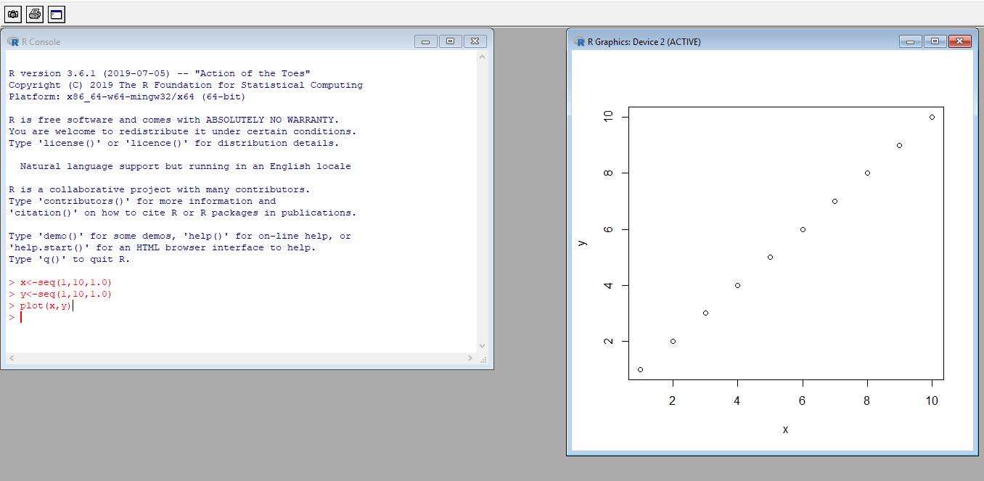

**>**x<-seq(1,10,1.0)

> y<-seq(1,10,1.0)

> plot(x,y)

> lmount<-lm(y~x)

> abline(lmount)

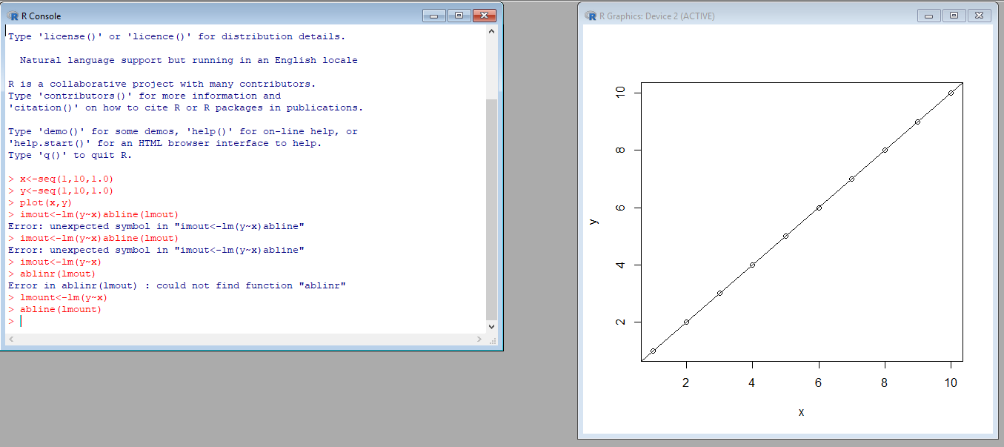

1. **Explain about probability distribution and execute normal distribution in R**.

Ans) A probability distribution describes how the values of random variable is distributed .

For example, the collection of all possible outcomes of a sequence of coin tossing is known to follow the binomial distribution . Whereas the means of sufficiently large samples of a data population are known to resemble the normal distribution. Since the characteristics of these theoretical distributions are well understood, they can be used to make statistical inferences on the entire data population as a whole.

Normal distribution :

The normal distribution is defined by probability density function .The normal distribution is important because of the Central Limit Theorem, which states that the population of all possible samples of size n from a population with mean μ and variance σ2 approaches a normal distribution with mean μ and σ2∕n when n approaches infinity.

Execution of normal distribution in R :  
for example:

Assume that the test scores of a college entrance exam fits a normal distribution. Furthermore, the mean test score is 72, and the standard deviation is 15.2. What is the percentage of students scoring 84 or more in the exam?

Sol) We apply the function pnormof the normal distribution with mean 72 and standard deviation 15.2. Since we are looking for the percentage of students scoring higher than 84, we are interested in the upper tail of the normal distribution.

> pnorm(84, mean=72, sd=15.2, lower.tail=FALSE)



Example 2:

Create sequence of numbers between -10 and 10 incrementing by 0.1

> x<-seq(-20,20,by=.1)

> y<-dnorm(x,mean=5.0, sd=1.0)

> plot(x,y, main="NORMAL DISTRIBUTION",col="blue")



Output:

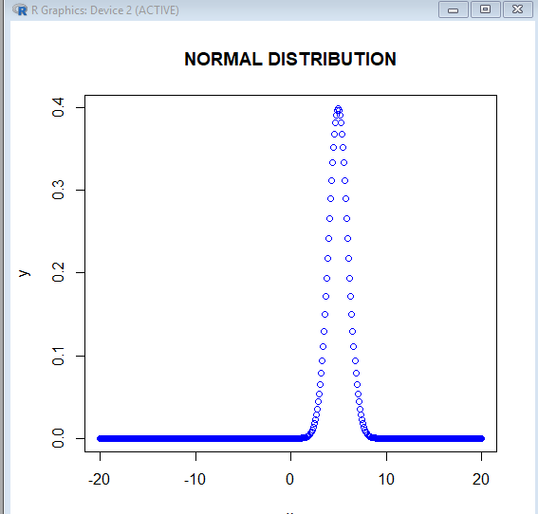

1. **Execute binomial distribution and create histogram with size 1 to 10 and probability 0.1 to 0.9 with n value 10.**

**Binomial distribution:**

Binomial distribution is a discrete probability . it describes the outcome of n independent trails in an experiment.

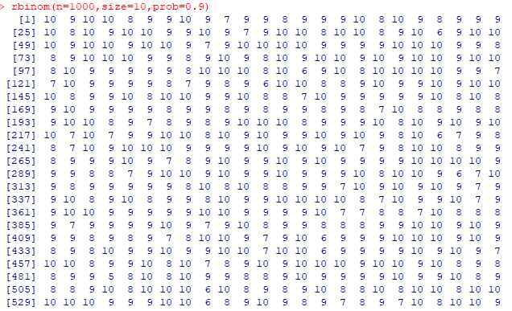

**Histogram**:

Histogram is a kind of box representation in graphs .”Hist” is the keyword to represent histogram. On x axis we represent the vector name and on y axis we represent the frequencies.

rbinom(n=1000,size=10,prob=0.9)

example:



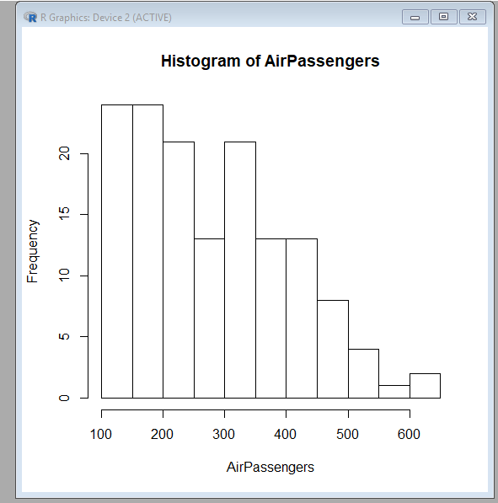

**N.Venkata Raju**

**18HP1A1257**